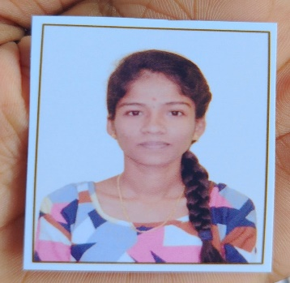 ***CURRICULUM VITAE***

**Name:-Ankita Irayya Naik**

**Phone:-+91 7483599065**

**E-mail:-ankitanaik072919@gmail.com**

**CAREER OBJECTIVE**

* **Obtain a responsible position in an organization with the best capabilities, skills and knowledge.**

**ACADEMIC QUALIFICATION:**

* **12th from MKS Honnavar**
* **10th from JVM Murdeshwar**

**PROFESSIONAL SKILLS:**

* **Basic knowledge in computer**
* **Typing**

**WORK EXPERIENCE:**

* **Fresher**

**PERSONAL DETAILS:**

**Fathers Name : Irayya Naik**

**Mothers Name : Susheela Naik**

**Date of Birth : 07-05-2005**

**Gender : Female**

**Nationality : Indian**

**Languages Known : Kannada , English**

**Hobbies : Writing and Reading**

**Place: Honnavar**